  Lab 9 Sequential logic  Part 2  Name : 01357101 Student ID : 黃翊宏 |  | Note  - All files must be converted to PDF format before submission.  Submission deadline: Next Tuesday at 1:00 PM  Each person submits one assignment.

※Please use Win + Shift + S for screenshots. Do not take photos of the screen with a phone.
- Lab 9-1：
Main Code Screenshot
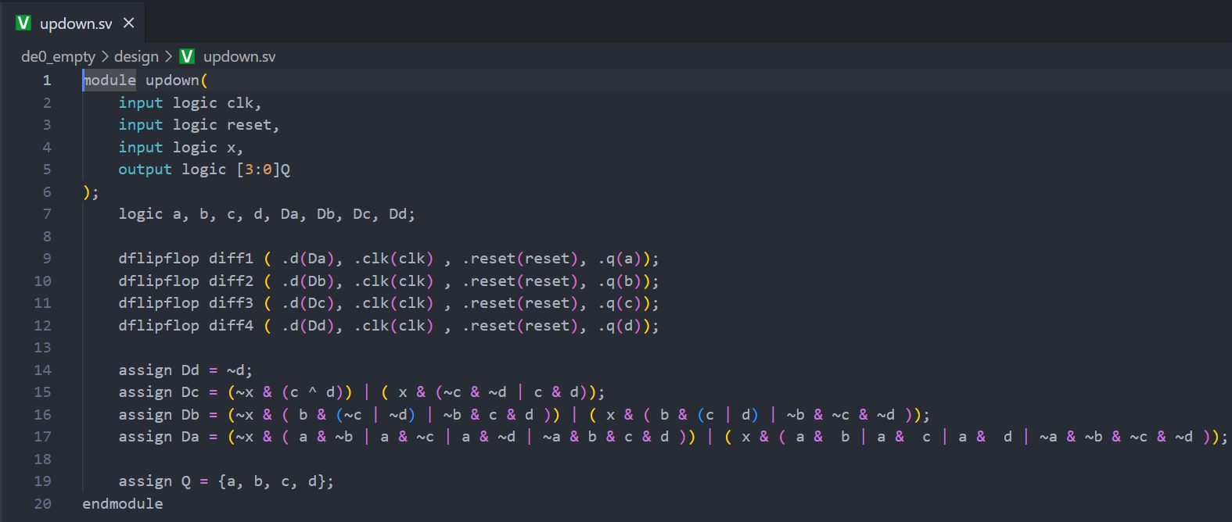
updown.sv

dflipflop.sv
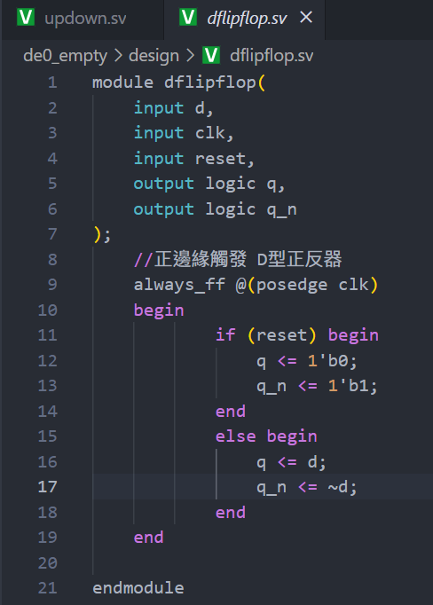
freg_div_23.sv
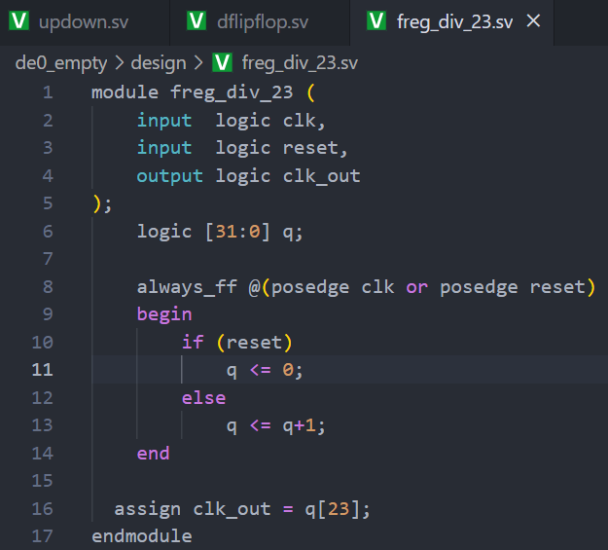

Karnaugh Map and Derivation Results (D_{A} D_{B} D_{C} D_{D} )
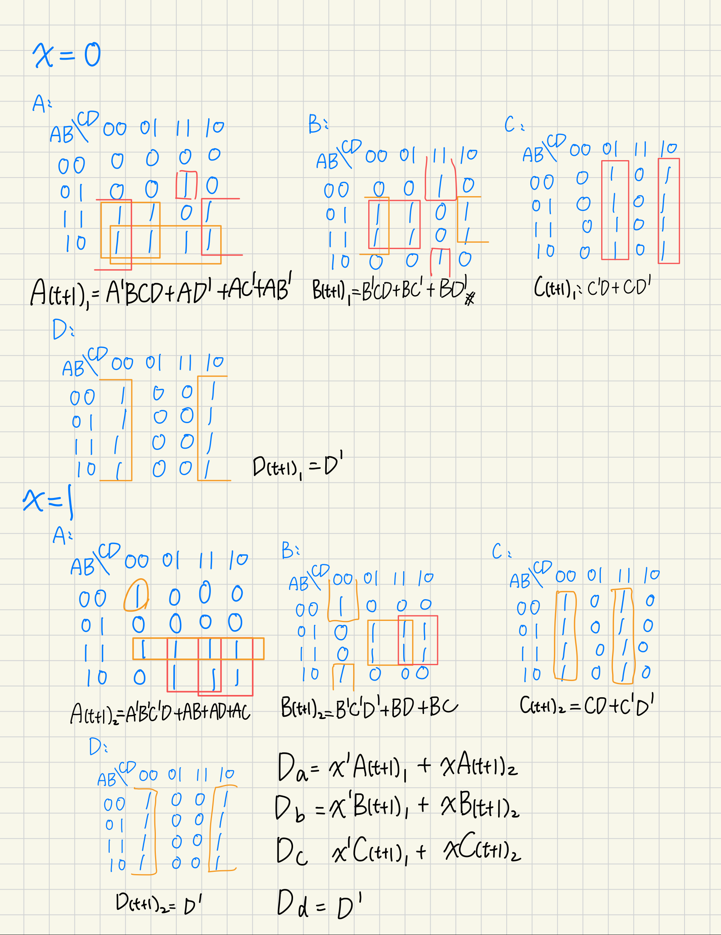

ModelSim Simulation Results
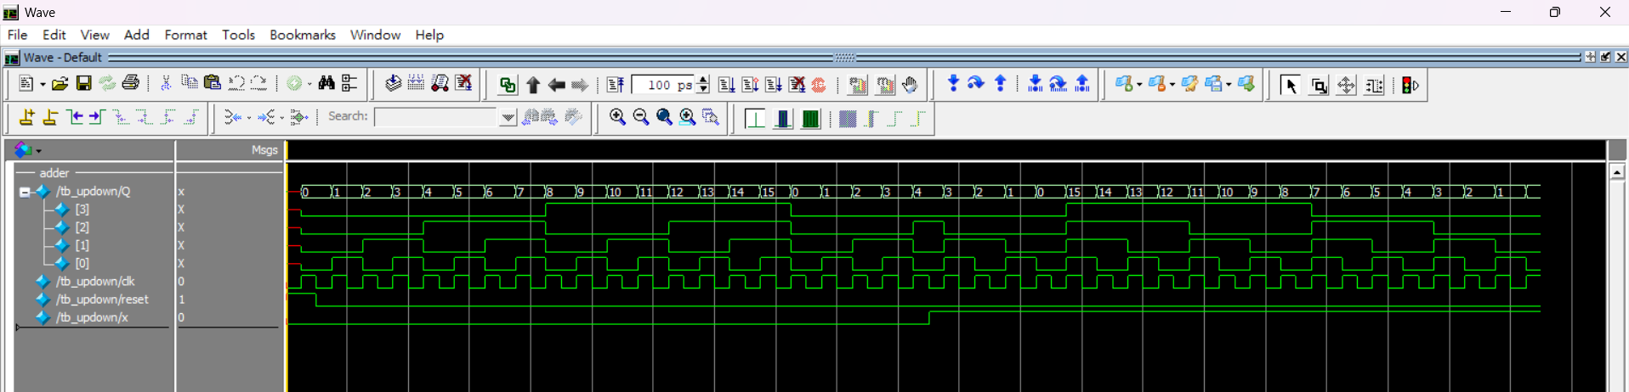

- Lab9-2：

Main Code Screenshot
rgy_top.sv
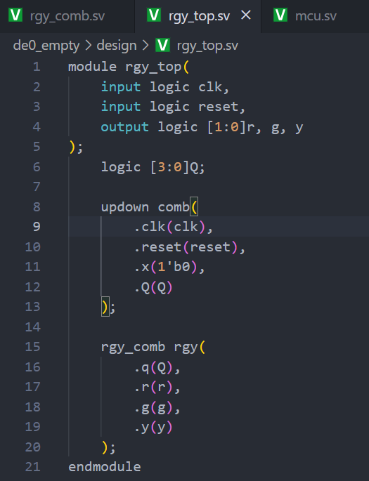
rgy_comb.sv
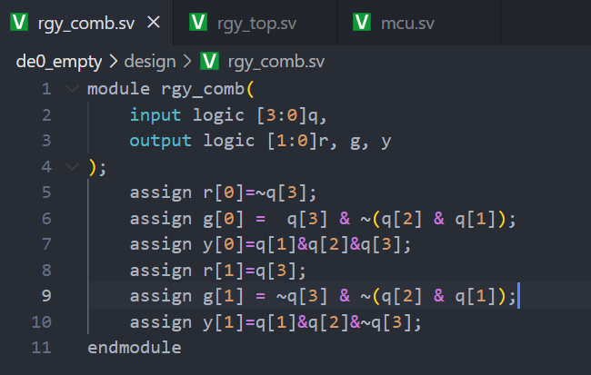
updown.sv same as the Lab1.

Karnaugh Map and Derivation Results (R、G、Y)


ModelSim Simulation Results
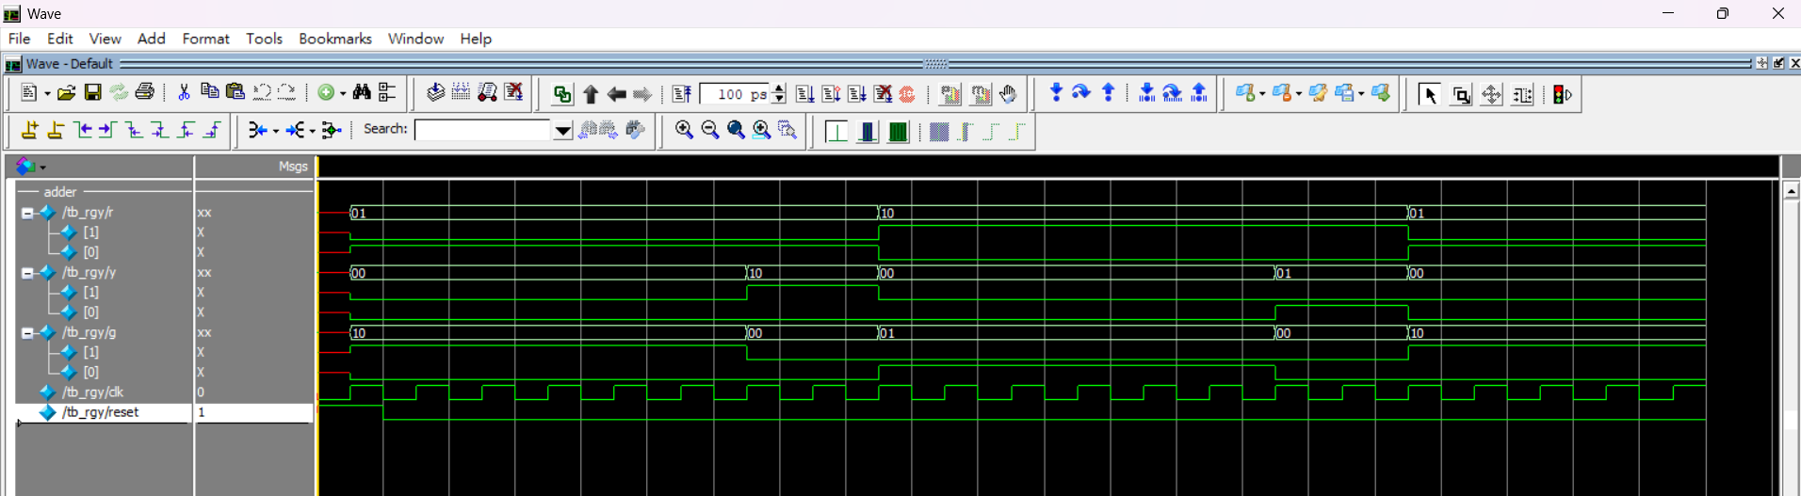

- Lab Summary and Reflection :
Summary:
In this experiment, we leveraged Quartus and the Altera DE0 development board to realize two complementary sequential‐logic systems in SystemVerilog: a 4-bit synchronous up/down counter and a dual traffic-light controller. For the counter, four D-flip-flops formed a register that, under the direction of an input signal, either incremented or decremented its 4-bit output. To make the count visually discernible on the seven-segment display, the on-chip 50 MHz clock was fed into a 32-bit register and its 23rd bit was tapped as a slow clock—effectively dividing the master clock by 2^24 . Following Karnaugh-map minimization, the next-state logic was coded in the updown.sv, dflipflop.sv, and freg_div_23.sv modules, and functional correctness was confirmed in ModelSim. On hardware, the seven-segment display reflected the count sequence in response to the switch-controlled up/down command and the reset button.
The traffic-light portion extended this framework by driving two separate red/green/yellow sets according to a 4-state machine. The rgy_top.sv and rgy_comb.sv modules decoded the counter’s two least significant bits into the prescribed lighting pattern—traffic-light set #0 cycling through red→green→yellow→red and set #1 offset by one state, cycling green→yellow→red→green . Simulation waveforms verified that each light adhered to its timing, and pin assignments mapped those signals to the DE0 board’s LEDs.
Reflection:
Through this lab, I deepened my grasp of synchronous sequential design, from state-diagram conception through hardware realization. Implementing the frequency divider underscored the importance of aligning simulation timescales with human‐perceptible rates, teaching me how to choose appropriate tap bits for clock division. Deriving combinational logic via Karnaugh maps reinforced systematic minimization, yet translating those expressions in SystemVerilog reminded me to vigilantly confirm signal widths and case sensitivities to avoid subtle synthesis errors. Integrating multiple modules into a single Quartus project further illuminated the necessity of precise port declaration and pin mapping for successful FPGA deployment. Overall, this exercise not only solidified my HDL coding and verification workflow but also honed my ability to iterate between simulation and hardware testing to achieve reliable digital designs.

